Dynamic Purchasing System for the Procurement of Printers and Scanners across the Government of Malta – DPS 020/20

Guidance Note for Contracting Authorities

**Date:** 14/11/2024

**Version:** 12.0

**Department:** FCD

**Unclassified**

# i Document Control Information

# Document reference

MITA-PRO-DPS 020_20 Guidance Notes-v12

# Document type

Procedure

# Security classification

Unclassified

# Synopsis

This document highlights the procedure to be followed by Government Contracting Authorities when issuing Specific Contracts related to the Dynamic Purchasing System for the Procurement of Printers and Scanners across the Government of Malta – DPS 020/20

# Document control

|  |  |  |
| --- | --- | --- |
| **Author** | **Change controller** | **Distribution controller** |
| Michaela Mifsud  Leader - Legal  (Contracts & Legal) | Richard Schembri  Manager (Contracts & Legal) | Richard Schembri  Manager (Contracts & Legal) |

This document may be viewed and/or downloaded from the MITA Procurement Website:

[**https://procurement.mita.gov.mt/resources/dps/dps-printers-scanners/**](https://procurement.mita.gov.mt/resources/dps/dps-printers-scanners/)

which maintains the latest issues of all documents and forms.

# Authorisation

|  |  |
| --- | --- |
| **Issuing authority** | **Approval authority** |
|  |  |
| **Signature / Date** | **Signature / Date** |
| Danielle Mercieca  Legal Advisor (Contracts & Legal) | Robert Grixti  Manager (Contracts & Legal) |

# 

# Modification history

|  |  |  |  |
| --- | --- | --- | --- |
| **Version** | **Date** | **Author** | **Comments** |
| Draft 0.1 | 15/02/2020 | Danielle Mercieca | Draft version for internal review |
| Version 1.0 | 11/05/2020 | Danielle Mercieca | First version for release |
| Version 2.0 | 15/10/2020 | Danielle Mercieca | Included guidance on purchase of OEM consumables. Minor amendments throughout. |
| Version 3.0 | 14/01/2021 | Danielle Mercieca | Updated reference to minimum time-limits for deadline for tender submissions. |
| Version 4.0 | 22/02/2021 | Danielle Mercieca | Updated reference to DCC approval for Specific Contracts above €10,000. |
| Version 5.0 | 27/05/2021 | Danielle Mercieca | Updated procedure for admittance to DPS and included references to Sectoral Procurement Directorate and Sectoral Procurement Units. Minor updates across. |
| Version 6.0 | 05/11/2021 | Danielle Mercieca | Included guidance on modifications, optional quantities and minimum threshold for DPS. Included reference to local Award Notice (no TED publication). Minor amendments throughout. |
| Version 7.0 | 14/03/2022 | Danielle Mercieca | Included reference to Procurement Originators Form and clarified uploading of documents for Specific Contracts estimated below €5,000. Included guidance on EU funded Specific Contracts. |
| Version 8.0 | 17/10/2022 | Danielle Mercieca | Replaced references to SPU with SPD and updated reference to GPP clearance above €5,000. Updated configuration requirements. Minor amendments throughout. |
| Version 9.0 | 21.12.222 | Robert Grixti | Updated guidance on EU funded Specific Contracts. |
| Version 10.0 | 14/03/2023 | Danielle Mercieca | Updated guidance on UBO Information Sheet for Specific Contracts. |
| Version 11.0 | 25/04/2024 | Robert Grixti | Updated screenshots to reflect new ePPS GUI.  Amended provisions on the percentage committed contract value of specific contracts, in line with DoC direction. |
| Version 12.0 | 14/11/2024 | Michaela Mifsud | Updated to remove the requirement to publish an advance notice in the Government Gazette (20 working days) prior to publishing a Specific Contract. |

Contents

i Document Control Information 2

ii List of Figures 5

iii Glossary 5

1. Purpose of the Guidance Note 6

2. What is a Dynamic Purchasing System (DPS)? 6

3. How a Contracting Authority is included in the DPS 7

4. Some considerations on the Specific Contract 8

5. Drawing up a Specific Contract 9

6. Using the Templates 9

7. Specific Contracts valued under €5,000 10

8. Invitation Document (for SCs valued over €5,000) 10

9. Contracting Templates (for SCs valued over €5,000) 11

10. Drawing up technical specifications 11

10.1 Purchase of Original Equipment Manufacturer (OEM) Consumables 12

10.2 Configuration Requirements 12

10.3 WEEE ‘Take-Back’ Obligations 12

11. Fees Schedule (For SCs valued over €5,000) 13

11.1 Fees Schedule (Purchasing) 13

11.2 Fees Schedule (Leasing) 13

12. Procurement Originators Form 13

13. Drawing up the Specific Contract on EPPS 14

13.1 Creating the Specific Contract 14

13.2 Adding Contract Documents 20

13.3 Invitation to Specific Contracts 21

14. Opening and Evaluation of Specific Contracts 23

14.1 Associating users 23

14.2 Opening 23

14.3 Evaluation 23

15. Award and Post-Award Obligations 24

15.1 Contract Award 24

15.2 Populating the Specific Contract 25

15.3 Post-Award Obligations 25

16. Useful References, Websites and Contact Details 26

Appendix A 27

Appendix B 28

# ii List of Figures

Figure 1 - The **List of CA DPAs** screen 8

Figure 2 – The DPS Workspace **DPS Menu** 15

Figure 3 – The **List of All Specific Contracts** screen and **Create Specific Contract** button 15

Figure 4 – The **Task List** from the User Homepage screen 16

Figure 5 – The **Define Tender Structure** link from the User Homepage screen 16

Figure 6 – The **CfT Tender Structure** screen 16

Figure 7 – The **Technical** screen within the CfT Tender Structure 17

Figure 8 – The **Define Section Element** screen 18

Figure 9 – The **Add Criteria** link within the Technical Sectionscreen 18

Figure 10 – The **Technical Define Criteria** screen 19

Figure 11 – The **Insert Financial Criteria** screen 19

Figure 12 – The **Define Financial Criwterion** screen 20

Figure 13 – The **Save Draft, Validate and Save Final** links from the **Management** Menu 20

Figure 14 – The **Add Contract Document** screen 21

Figure 15 – The **Invitations** screen (no invitation possible) 21

Figure 16 – The **Send Invitations** link in the EPPS Task list. 21

Figure 17 – The **Invitations** Screen. 22

Figure 18 – The **Create New Invitation** Screen. 22

# iii Glossary

|  |  |  |  |  |  |  |  |
| --- | --- | --- | --- | --- | --- | --- | --- |
| **CA** | Contracting Authority | **MPU** | | | Ministerial Procurement Unit | | |
| **CfT** | Call for Tenders | **OEM** | | | Original Equipment Manufacturer | | |
| **CPB** | Central Purchasing Body | **OPM** | | | Office of the Prime Minister | | |
| **CPV** | Common Procurement Vocabulary | **PCRB** | | | Public Contracts Review Board | | |
| **DCC** | Departmental Contracts Committee | **PPR** | | | Public Procurement Regulations | | |
| **DoC** | Department of Contracts | **PO** | | | Purchase Order | | |
| **DPS** | Dynamic Purchasing System | **POF** | | | Procurement Originators Form | | |
| **EO** | Economic Operator |  | | **PO/ES** | | Purchasing Officer/Evaluation Staff | | |
| **EPPS** | Electronic Public Procurement System |  | **PO/ESR** | | | Purchasing Officer/Evaluation Staff-Responsible |
| **GDPR** | General Data Protection Regulation |  | **PO/OS** | | | Purchasing Officer/Opening Staff | | |
| **GPP** | Green Public Procurement | **SPD** | | | | Sectoral Procurement Directorate | | |
| **LoE** | Letter of Engagement | **SC** | | | Specific Contract | | |
| **MFIN** | Ministry for Finance and Financial Services | **UBO** | | | Ultimate Beneficiary Owner | | |
| **MITA** | Malta Information Technology Agency | **WEEE** | | | Waste Electrical & Electronic Equipment | | |
|  |  | **XML** | | | Extensible Markup Language | | |
|  |  |  | | |  | | |

# Purpose of the Guidance Note

The purpose of the Guidance Note is to provide assistance to Contracting Authorities in issuing Specific Contracts under the Dynamic Purchasing System established by the Malta Information Technology Agency (MITA) for the Procurement of Printers and Scanners across the Government of Malta – DPS 020/20.

The Guidance Note is intended to supplement the numerous instructions found throughout the standard tender and contract templates provided, by specifically noting key points or main sections of the documents, and to provide a chronological overview of the steps required for the procurement process on EPPS.

One standard template is provided for the Invitation Document whilst two separate templates are provided for the subsequent contracts: a Purchase Order Letter (PO) for outright purchase of hardware equipment, and a Letter of Engagement (LoE) for the leasing of equipment. A Technical Specifications template with baseline specifications shall also be maintained in order to serve as a guideline for the CAs to build their specification on. Two fees schedule templates are also available: one for the purchasing of hardware and the other for leasing of equipment.

# What is a Dynamic Purchasing System (DPS)?

A Dynamic Purchasing System (DPS) is a procurement procedure that can be used to procure commonly and repeatedly-used purchases, which are generally available on the market, whilst speeding up the process and reducing the administrative burden on the part of all stakeholders. A DPS is similar to an electronic framework agreement, with two exceptions:

* new Economic Operators (EOs) can join a DPS at any time and
* it can only be run as a completely electronic process.

The DPS procedure is catered for in Regulations 174 to 180 of the Public Procurement Regulations (Legal Notice 352 of 2016). DPS is considered as a restricted procedure in terms of the Regulations

A DPS can be established by a Central Purchasing Body (CPB) in respect of an identified type of requirement, which may be divided into categories of products, services or works.

The DPS has two main stages:

1. Establishment of the DPS: The DPS is established by the CPB and runs for a determined period (in years). At any point during the DPS term, Economic Operators (EOs) may apply to be admitted to the DPS and be invited to specific contracts. The EOs’ administrative eligibility is determined by the CPB at this stage.
2. Issuing of Specific Contracts (SCs): Specific Contracts for particular purchases related to the broad categories/requirements of the DPS are issued. All Admitted participants are invited to tender, who only have technical and financial information to submit. The EOs’ technical and financial offers are evaluated at this stage

# How a Contracting Authority is included in the DPS

MITA, as a Central Purchasing Body administers the establishment of the DPS, which may comprise any Contracting Authorities listed in Schedule 1 of the Public Procurement Regulations 2016 into the DPS, through EPPS. In line with the **OPM interoffice memorandum,** those Contracting Authorities with a strong business case for procurement outside the DPS, are to put their request to the Office for the Permanent Secretary (Strategy and Implementation) for further consideration. Should their request be acceded to, they can procure/lease hardware outside this DPS.

**Specific Contracts below €10,000:**

CA authorised representatives are to contact the MITA Manager (Contracts and Legal) on [dps.mita@gov.mt](mailto:dps.mita@gov.mt) asking for their CA to be added as a participant to this DPS. The CA is to provide its active CA name as shown in the EPPS. In case the CA does not have an active EPPS account, it needs to contact the Department of Contracts on [etenders@gov.mt](mailto:etenders@gov.mt) in order to have its account created.

MITA shall add the CA to the active list of participants to this DPS within the shortest timeframes possible, by not later than the next working day from the date of the receipt of application.

**Specific Contracts exceeding €10,000:**

Pursuant to the provisions of Contracts Circular 04/2021, Ministerial Procurement Units (MPUs) have been replaced by a Sectoral Procurement Directorate (SPD) within the Department of Contracts. The SPD is responsible for the administration, evaluation and recommendation of Calls for Tenders published under both open and restricted procedures where the Procurement Estimated Value exceeds ten thousand Euro (€10,000) excluding VAT but does not exceed the value of seven hundred and fifty thousand Euro (€750,000) excluding VAT, including Specific Contracts under the DPS. A number of units within the Sectoral Procurement Directorate (SPDs) have been set which shall be responsible for issuing of SCs on behalf of CAs that fall under their responsibility.

The Sectoral Procurement Directorate has been admitted as a participant to the DPS and all Specific contracts under the DPS within the estimated values mentioned above are to be published through the SPD EPPS account. All users of Sectoral Procurement Directorates (SPDs) associated with the SPD account on EPPS will be able to issue specific contracts.

Schedule 16 Contracting Authorities previously admitted to the DPS are to ensure that they do not publish specific contracts through their own EPPS accounts, when the Specific Contract exceeds €10,000 and to liaise with their respective SPDs for publication.

In the case of Schedule 2 and Schedule 3 Contracting Authorities issuing Specific Contracts exceeding €10,000 and which do not fall under a designated SPD, CAs are to carry out all stages detailed in these Guidance Notes.

The DPS will be available to view from the **List of ca dps** under the **cft management** menu.

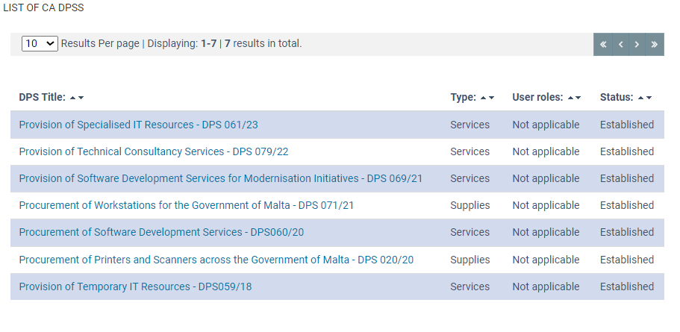

Figure 1 - The **List of CA DPSs** screen

For a detailed explanation of the allocation of responsibilities of Contracting Authorities and SPDs depending on whether the CA falls under Schedule 2, 3 or 16 of the Public Procurement Regulations, please refer to Appendices A and B of these Guidance Notes.

# Some considerations on the Specific Contract

A Specific Contract (SC) is the term used to identify the tender document that is sent to tenderers when the procurement is carried out through a DPS. The following considerations are to be kept in mind:

1. SCs may start being issued by those CAs which are part of the DPS after 30 days from the establishment of a DPS – please liaise with the MITA Manager (Contracts and Legal) in case of difficulty.
2. No SC invitations can be issued if an Economic Operator (EO) admittance application is still pending – please liaise with the MITA Manager (Contracts and Legal) to check whether there are any pending applications preventing from publishing a SC.
3. Specific Contracts shall only be issued electronically, through the EPPS (<https://www.etenders.gov.mt/>)
4. A minimum value of €1,000 excluding VAT is being set for the value of each Specific Contract.
5. Until otherwise directed by MITA, the value of each SC shall not exceed the following total values:
   1. **€139,000 excluding VAT** when the CA is listed in **Schedule 2** of the PPR
   2. **€250,000 excluding VAT** when the CA is listed in **Schedule 3 or Schedule 16** of the PPR
6. CAs shall retain their own authorisation levels/procedures for the issuance and award of Specific Contracts.
7. CAs shall commit funds to cover the expenses related to these Specific Contracts out of their own budget.
8. Sectoral Procurement Directorates (SPDs) shall be responsible for issuing SCs for those CAs that fall under their responsibility.
9. Unless otherwise instructed by MITA, all economic operators that are admitted to the DPS at the time of issuing the Specific Contract are invited to participate.
10. Contracting Authorities shall make use of the templates provided in terms of the invitation document and Specific Contract, with no alteration/deviation unless otherwise provided for in the same templates.
11. Contract management and performance monitoring, as well as all payments due under Specific Contracts shall be handled directly by the Contracting Authorities concerned.
12. The nature of the services must be drawn up under the proviso that a DPS caters for commonly used purchases the characteristics of which, as generally available on the market, meet the requirements of the Contracting Authorities. It is therefore reiterated that Specific Contracts awarded through this DPS shall not be subject to modifications, extensions or renewals. Any additional services would need to be procured via the publication of a new Specific Contract. Therefore, Ministries and Entities are expected to pay particular attention to ensure proper planning of their procurement needs and requirements and are advised against any attempt towards circumvention through any means whatsoever.

# Drawing up a Specific Contract

1. A SC will require information of a technical and financial nature only.
2. A SC will follow the restricted procedure from a procurement point of view, meaning that only those invited participants will be able to submit a bid. In terms of other procurement matters, the specific contract will be managed like a conventional tender in respect to:
   1. A fixed deadline for submission of tender online through EPPS
   2. Clear delineation of the award criteria (e.g. Cheapest Technically Compliant)
   3. Evaluation Process
   4. Notifications to successful/unsuccessful tenderers
   5. Appeals procedure
   6. Signing of a contract (Purchase Order or Letter of Engagement)

# Using the Templates

The CPB has provided templates for mandatory use in the issuing of Specific Contracts under the DPS. These include:

**For Specific Contracts valued under €5,000:**

* A single Specific Contract template

**For Specific Contracts valued over €5,000:**

* Specific Contract (Invitation Document)
* Baseline Hardware Specifications (to be incorporated in the Specific Contract)
* Mandatory General Requirements
* Fees Schedule (leasing or purchasing)
* Purchase Order Letter
* Letter of Engagement

These templates may be downloaded from the URL:

[**https://procurement.mita.gov.mt/resources/dps/dps-printers-scanners/**](https://procurement.mita.gov.mt/resources/dps/dps-printers-scanners/)

and may be updated from time to time. It is therefore important to peruse the aforementioned link in order to ensure that the latest templates are utilised.

# Specific Contracts valued under €5,000

For low-value purchases of equipment and/or consumables, procurers may make us of the **Specific Contract Template (Under €5,000)** template. This is an all-encompassing template that comprises the instructions to participants, contractual details, technical specifications, financial offer, mandatory general requirements, and award requirements/adjudication procedure. The considerations of Section 10 below are to be kept in consideration when drawing up this Specific Contract.

There is no need to draw up a contractual Purchase Order/Letter of Engagement in such a procurement process. Upon award, an Accounts purchase order/letter of acceptance is to be drawn up, with Sections 1-4 of this template being annexed to it. Any relevant tender documentation that was submitted by the awarded bidder at tendering stage is also to be annexed to the purchase order/letter of acceptance.

# Invitation Document (for SCs valued over €5,000)

The Invitation Document is based on the DoC template for open tenders, without the eligibility and selection criteria usually included in the latter. The Invitation Document would thus be comprising:

* The Instructions to Tenderers, linking with the General Rules Governing Tenders
* The Technical Specifications/Terms of Reference
* The Financial Schedule
* Any supplementary documentation (for example, the Glossary) and templates (for example, the Performance Guarantee Specimen)

|  |
| --- |
| **⮊ Important Note:** In the case of leasing, should it be foreseen that additional printers may be needed, the budget estimate should factor in the cost of such optional quantities and the terms of reference should indicate this possibility by including the following text:  *“The Contracting Authority reserves the right to lease additional multi-function device/s. This addition will not entail an increase in the quantity of copies or in the original contract value.*  *The Contracting Authority will notify the Supplier of the additional printer/s required and the location of delivery. All other terms and conditions, including but not limited to the period for delivery and penalties for mere delay, will apply.”*  It is recommended that the supply of refurbished printers is allowed in this circumstance. |

|  |
| --- |
| **⮊ Important Note: Ultimate Beneficiary Owners (UBOs)**  For specific contracts with an estimated value which exceeds €10,000 excluding VAT, the technical requirements must include a declaration committing the tenderer to provide a filled in UBO Information Sheet and any supporting documentation once the Specific Contract is awarded. The UBO form is available in the standard templates of the EPPS for visibility by the Economic Operators.  Contracting Authorities are to ensure that, following award, the recommended bidder submits the filled in UBO Information Sheet. The form is to be retained by the Contracting Authority and a copy is to be forwarded to DoC on [compliance.contracts@gov.mt](mailto:compliance.contracts@gov.mt) |

# Contracting Templates (for SCs valued over €5,000)

Once the Invitation Document is finalised, CAs are to decide on the choice of Purchase Order (PO) or Letter of Engagement (LoE) template depending on whether the equipment is to be purchased or leased. The following steps can be followed concerning the drafting of the contract:

* Review the appropriate template, taking note of the salient provisions;
* Field greyed out must be filled in or removed if not applicable. These include:

1. The contract reference
2. Equipment type to be purchased/ leased
3. Period for delivery, installation and commissioning of equipment
4. Period for the provisions of maintenance services
5. Warranty period for equipment
6. Penalty amounts for mere delay
7. Amend list of maintenance services according to procurement requirement
8. Frequency of preventive maintenance visits
9. Service Levels by filling in response/ resolution times
10. Coverage hours for maintenance services
11. Penalty amounts for breach of Service Levels

* Leave details relating to tenderer and contracting authority greyed out;
* Price, requirements and technical specifications in Appendix A are also to be left greyed out;

The Contract Template is to be published with the Invitation Document as outlined in Section 11.2.

# Drawing up technical specifications

Technical specifications are to be drawn up in line preferably incorporating the baseline requirements as detailed in the Technical Specifications Template provided by the CPB. Any detailed additional requirements are to be specified according to the CAs specific procurement requirements and needs in the Invitation Document.

The CPB cannot provide case-by-case assistance with respect to technical specifications; CAs shall be provided with:

1. A set of mandatory requirements that the tenderer is to confirm adherence to, and
2. A baseline Technical Specifications Template as guidance on the most pertinent specifications related to the equipment.

Every CA shall be responsible for drawing up and parameterize their own technical specifications which must then be transposed onto the EPPS in order to be evaluated.

|  |
| --- |
| **⮊ Important Note:** Contracting Authorities are to ensure all relevant GPP criteria are included in Specific Contracts, including any updates to these requirements, as detailed in the Green Public Procurement National Action Plan 2022-2027: <https://environment.gov.mt/en/decc/Pages/environment/gpp/secondNap.aspx> |

## 10.1 Purchase of Original Equipment Manufacturer (OEM) Consumables

Technical specifications may require **branded new** consumables (ink cartridges, toner cartridges, developers, drums, as well as 3D printer-related consumables such as filaments and build sheets) from the **Original Equipment Manufacturer (OEM)** on condition that:

1. The hardware equipment requiring such consumables is still under warranty, or
2. The Contracting Authority obtains a **written attestation** from the OEM stating that the use of original consumables is recommended for the optimal use of the hardware equipment and the mitigation of errors and malfunctions, when the hardware equipment is no longer covered by warranty

The Contracting Authority may (at their own risk and discretion) opt to allow for **remanufactured** and/or **compatible** consumables to be proposed (besides OEM consumables), in case where the equipment’s warranty has expired

The tender requirements shall **explicitly state** whether original-only, or original/compatible consumables are being requested. In case where only original consumables are requested, the tender requirements must include the **proper justification** for this choice, by stating the conditions justifying this same choice (as per points 1 and 2 above).

## 10.2 Configuration Requirements

Technical specifications related to printers/scanners that are going to route emails through MITA SMTP relay service must include the configuration requirements that are available from:

[https://mita.gov.mt/call-centre/#Printer-ScanToMailInformation](https://eur01.safelinks.protection.outlook.com/?url=https%3A%2F%2Fmita.gov.mt%2Fcall-centre%2F%23Printer-ScanToMailInformation&data=04%7C01%7Cdanielle.c.mercieca%40gov.mt%7C2cd2589faf9f45d48c2e08da08b44907%7C34cdd9f55db849bcacba01f65cca680d%7C0%7C0%7C637831867654990715%7CUnknown%7CTWFpbGZsb3d8eyJWIjoiMC4wLjAwMDAiLCJQIjoiV2luMzIiLCJBTiI6Ik1haWwiLCJXVCI6Mn0%3D%7C3000&sdata=HWXaHgKDx9%2FpQqxSJY7vMB%2BE5D7y31pgai3CsZWlqLI%3D&reserved=0)

## 10.3 WEEE ‘Take-Back’ Obligations

Where outright purchasing is concerned, the mandatory technical requirements are to include a declaration that ensure compliance by suppliers and/or producers with the Waste Management (Electrical and Electronic Equipment) Regulations (Subsidiary Legislation 549.89). Under these regulations, producers and, in certain cases resellers of electronic equipment, have certain obligations in relation to the collection and treatment of waste of electronic equipment at the end of the life-cycle. These obligations apply to those who:

* Manufacture EEE in Malta and sell in Malta
* Resell in Malta EEE producer by other suppliers, under his own name/ trademark, provided the brand of the producer does not appear on the equipment
* Import EEE into Malta on a professional basis from an EU Member State or 3rd country
* Sell EEE by means of distance communication from another Member State or 3rd country directly to users in Malta

# Fees Schedule (For SCs valued over €5,000)

Two Fees Schedule templates are available to use, depending on the nature of the Specific Contract.

## 11.1 Fees Schedule (Purchasing)

This template is to be used in respect of outright purchasing of equipment or consumables. This Schedule is to include details related to the equipment/consumables being purchased, and, if applicable, details relating to preventive and/or corrective maintenance services. The invoicing and payment terms are included in this Schedule for greater visibility.

## 11.2 Fees Schedule (Leasing)

This template is to be used in respect of leasing of equipment, mainly printers, and only requires the rate per copy which is construed to factor for all costs related to the delivery of the supply/service requested. The invoicing and payment terms are also included in this Schedule for greater visibility.

|  |
| --- |
| **⮊ Important Note:** Currently practices do not allow a tendered rate with more than two decimal figures. In view of the nature of the leasing services, a rate per copy is not recommended since this would mean that bids cannot be below €0.01. The Fees Schedule ought to seek a rate per multiple (e.g. 100) copies, in order to seek more competitive pricing. |

# Procurement Originators Form

After all documents pertaining to the Specific Contract are finalised, Contracting Authorities are to fill in the Procurement Originators Form (POF) with the following details:

* Department/ Ministry
* Procurement Reference
* Procurement Description/ Title
* Procurement Type – **Services** or **Supplies**
* Procurement Procedure – which is to be set as **DPS 020/20: Specific Contract**
* Funding Source (locally-funded, EU co-funded, or as appropriate)
* Estimated value excl. VAT, Estimated potential cost and Total estimated value of procurement
* CPV Number/s
* Completion/ Delivery Period
* Project Leader/ Manager
* Indicate which officers have prepared the various documents for the Specific Contract
* Indicate the appropriate answers in the GPP sections.
* Indicate the appropriate answers in the Data Processing section.

For Specific Contracts valued in excess of €5,000, before publishing the SC, Contracting Authorities must obtain GPP clearance by sending the signed Procurement Originators Form to their respective GPP Office for publication clearance. Invariably, a POF is required for every SC issued through this DPS. Every CA is responsible for including all details pertaining to the Specific Contract to be issued in the POF and SPDs are to forward a signed copy to the CPB on [dps.mita@gov.mt](mailto:dps.mita@gov.mt) as soon as the SC is cleared to be issued.

|  |
| --- |
| **⮊ Important Note:** Modifications or extensions on Specific Contracts are not permitted therefore any possible extensions or modifications are to be treated as optional items of expenditure, which are to be considered as part of the estimated value of the Specific Contract (rather than potential costs). In all other cases, once the Specific Contract expires or all funds are exhausted before the expiry of the contract, another Specific Contract would need to be issued.  By special concession to DoC Circular No 10/2021 and **only with respect to Specific Contracts issued through this DPS**, the Director General (Contracts) has provided for a threshold of 60% committed value of the total estimated contract value. Therefore the value of **optional items cannot exceed 40% of the estimated contract value.** |

|  |
| --- |
| **⮊ Important Note: EU Funded Specific Contracts**  In order to ensure that publication through the DPS adheres to the public procurement principles, it is important for new suppliers being able to bid. With this in mind, this would necessitate an advance notice (20 working days) in the Malta Government Gazette (and the Official Journal of the EU for amounts more than €140,000). Raising awareness through other media can complement the publication on the Gazette and Journal.  The appropriate Managing Authority is to be consulted in case of further clarification being required. |

# Drawing up the Specific Contract on EPPS

## 13.1 Creating the Specific Contract

In order to create a Specific Contract in the context of the DPS Procurement of Printers and Scanners across the Government of Malta DPS 020/20, from the DPS menu, select the **create specific contract** link:

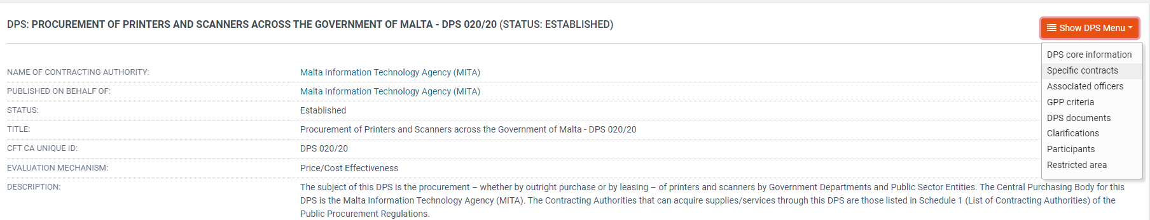

Figure 2 – The DPS Workspace **DPS Menu**

Once the page is loaded, Specific Contracts can be created by clicking the **create specific contract** button:

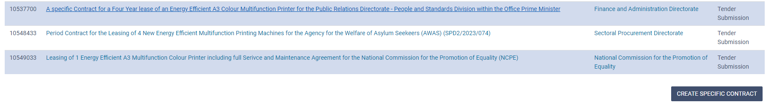

Figure 3 – The **List of All Specific Contracts** screen and **Create Specific Contract** button

In the following **create specific contract** screen, the following information is to be provided:

* Specific Contract Title *
* CfT CA Unique ID
* Description of the specific contract *
* Name of CA (‘Published on Behalf of:’ searched from the Search for code link) *
* Estimated value *
* Time limit for submission of tenders*
* If documents can be uploaded within clarifications *
* If the Specific Contract is EU-funded
* If multiple offers will be accepted
* If the CfT falls under the scope of Green Public Procurement (GPP) *
* If Certification Checks are required*

* These fields are mandatory.

The following information is pre-filled and no user intervention is required:

* Procurement type
* Procedure
* Directive
* CfT involvement
* CPV Codes
* Inclusion of e-Auctions
* Payment Options
* Evaluation Mechanism

Once all the information is filled in, click the **create cft workspace** button.

Once the CfT Workspace has been created, two tasks will be shown in the user’s EPPS homepage:

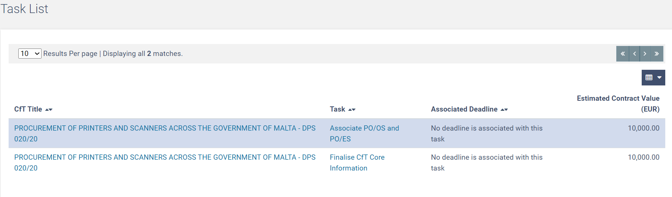

Figure 4 – The **Task List** from the User Homepage screen

The **finalise cft core information** link is to be selected in order to make some final edits to the Workspace (for example, setting the time-limit for the submission of tenders for the Specific Contract). Click the **save changes** button to save any modifications to the Workspace.

The **define tender structure** will now be displayed in the List of Tasks.

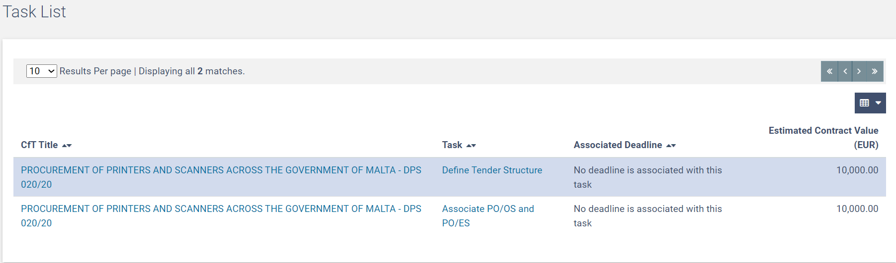

Figure 5 – The **Define Tender Structure** link from the User Homepage screen

The user must define the tender structure by indicating whether the tender structure defined for the DPS will be imported and whether the tender structure will be imported from a pre-defined XML file.

|  |
| --- |
| **⮊ Important Note:** A baseline XML File Structure is available for use for Specific Contracts for the purchase of equipment/and or consumables valued under €5,000. This baseline XML Structure may be amended as required. |

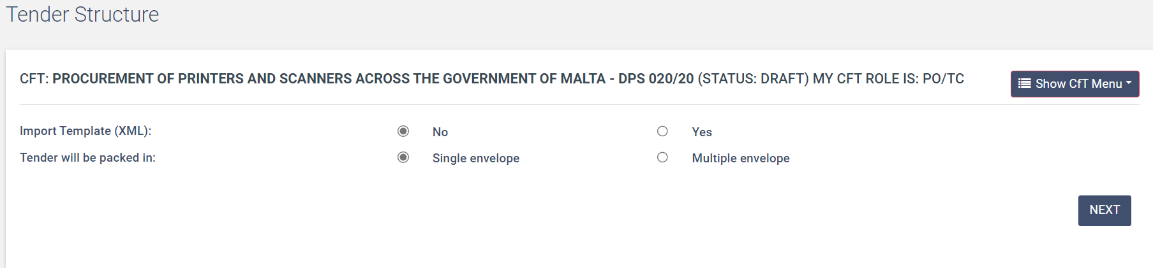

Figure 6 – The **CfT Tender Structure** screen

A pre-defined XML file is available as part of the resources for this DPS, with respect to Specific Contracts estimated under €5,000. The user may import and amend this XML as may be required.

CAs are responsible for creating the technical sections and criteria required in EPPS, in accordance with the details included in the Invitation Document, unless otherwise advised by the SPD. Unlike the creation of an open tender CfT, no information relating to the administrative aspects (eligibility and selection criteria) are to be included in the CfT Tender Structure.

|  |
| --- |
| **⮊ Important Note:** When drafting the technical requirements, special attention should be given to the performance characteristics of the hardware being sought. These performance characteristics could be achieved through a variety of technologies (for example, in the case of leasing of multifunction printers, by machines using laser or inkjet technology). The specifications should therefore, unless otherwise necessitated by any specific justification, allow for competition between differing technologies to the greatest extent possible. |

|  |
| --- |
| **⮊ Important Note:** Procurers are to keep note of the provisions of the GDPR when setting the technical specifications of the hardware being procured. Elements such as a hard drive/memory to store prints/scans, connection to networks/cloud, and user authentication have an element of processing of personal data involved. Adequate provisions from a GDPR perspective should be included as may be appropriate. |

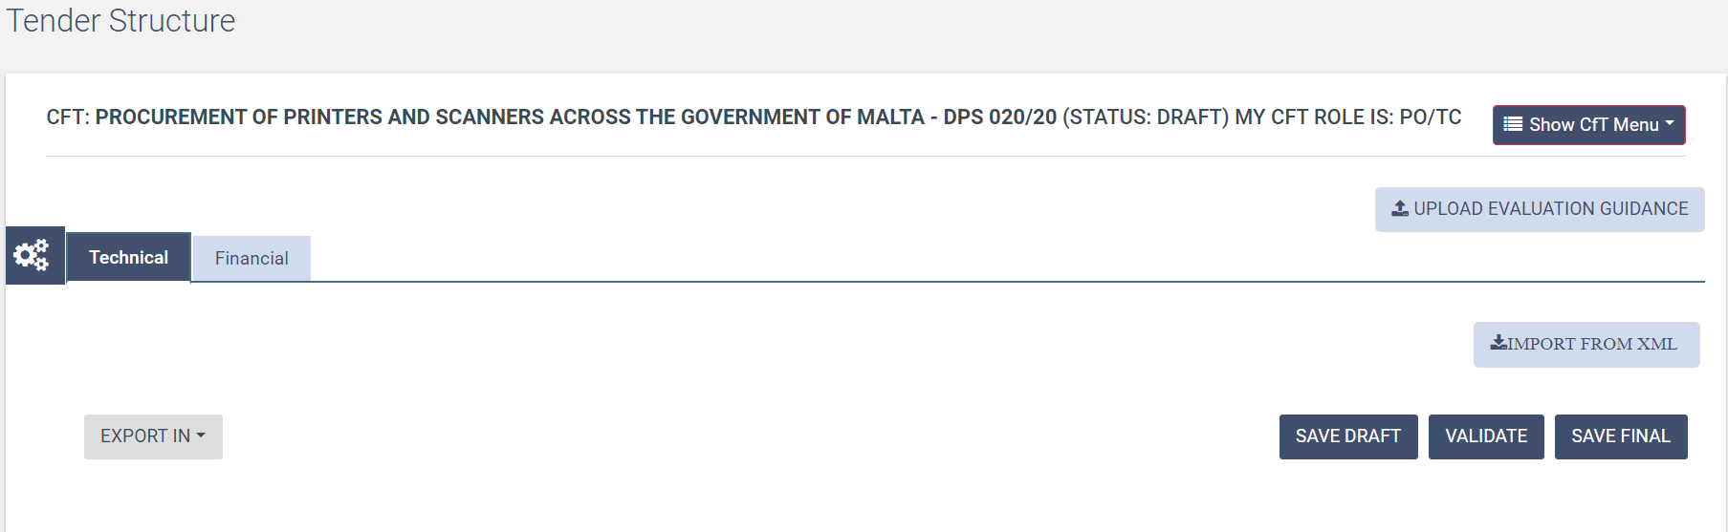

Figure 7 – The **Technical** screen within the CfT Tender Structure

In order to insert the technical criteria, a minimum of one Section is to be created. In order to do so, from the **technical** tab:

* Select ‘Definition’ button
* Select ‘Add Section’
* In the new window fill the field entitled ‘Label’
* Press ‘Submit’

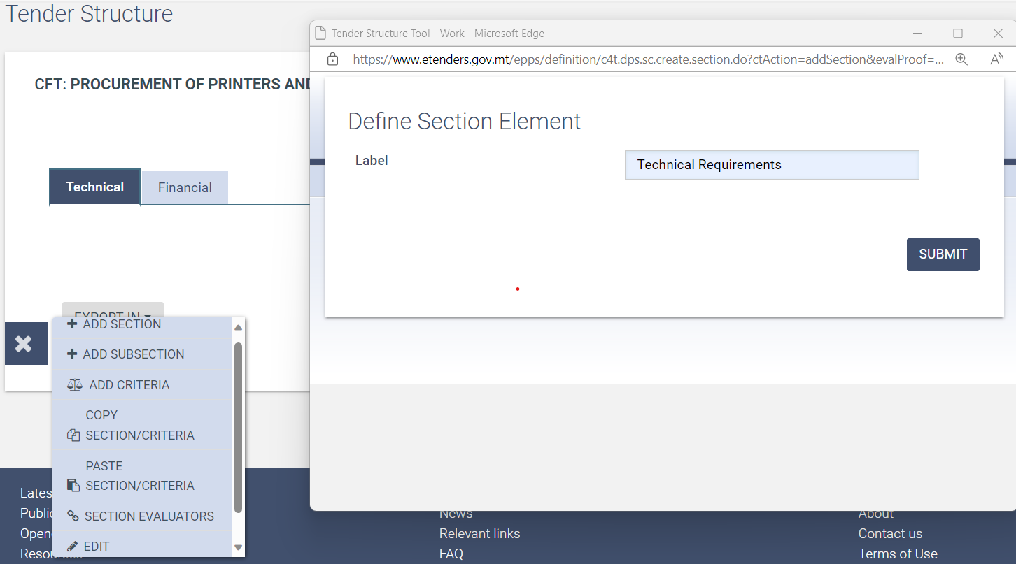

Figure 8 – The **Define Section Element** screen

Multiple sections and sub-sections can be created. It is however recommended to keep the Technical Structure as simple and streamlined as possible.

To add technical criteria within the Section, ensure that the relevant Section’s radio button is checked, and the select **add criteria** from the Definition menu.

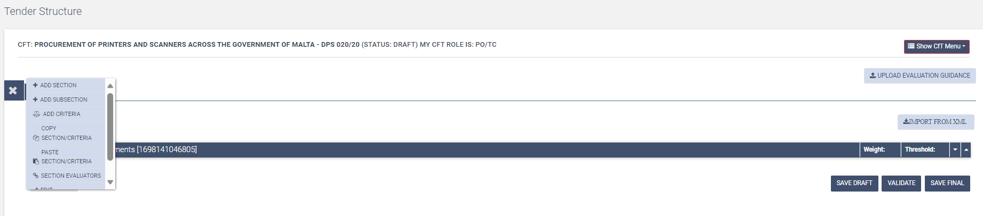

Figure 9 – The **Add Criteria** link within the Technical Sectionscreen

From the resultant new window, fill in/select the following details:

* Type- choose from Text field, Text area, Number, Date, File or List
* Label
* If mandatory criteria or not
* If Supplier read only
* If textual evaluation
* If criterion included in Evaluation and if yes, the weight and threshold for the criterion
* Press ‘Submit’

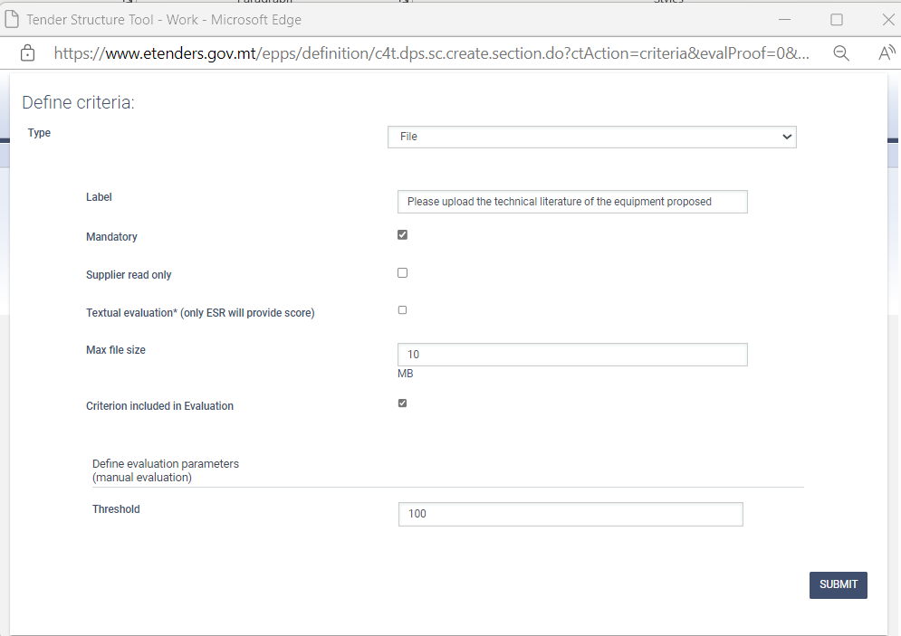

Figure 10 – The **Technical Define Criteria** screen

Criteria may be added, removed, or edited until the CfT Structure is finalised.

Financial criteria need to be included from the **financial** tab:

* Define the financial evaluation approach (whether the financial element will be a pass/fail component of the Specific Contract evaluation, or not)
* To add financial criteria, select the select **insert financial criteria** from the Definition menu.

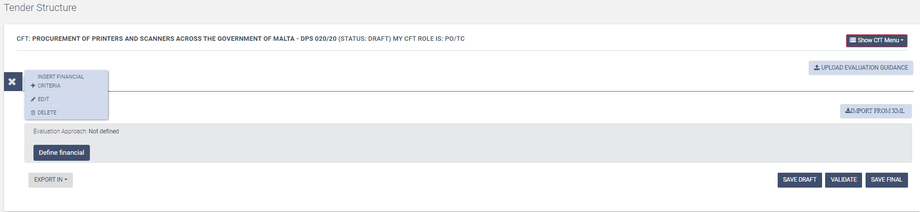

Figure 11 – The **Insert Financial Criteria** screen

* From the new Window, set the appropriate label, and check whether the criterion is mandatory, and if the document attachment is mandatory. Click the **Submit** button to save settings.

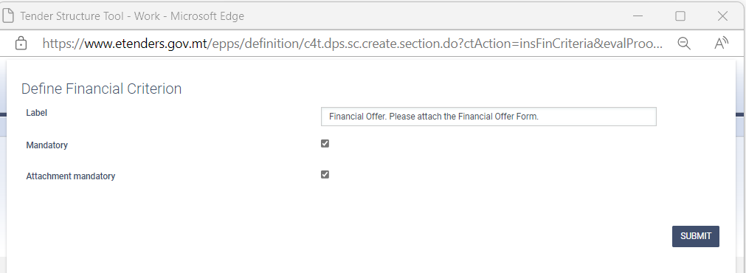

Figure 12 – The **Define Financial Criterion** screen

Once all technical and financial criteria are defined, the user can proceed with finalizing the Specific Contract Tender Structure:

* It is important that the user clicks the **save draft** link from the **management** button, if the technical/financial criteria are not finalised – otherwise any additions or changes will be lost.
* The user should click the **validate** button to ensure that the XML structure is validated successfully, thus ensuring that the Specific Contract structure is complete.
* The Specific Contract Tender Structure is finalised by clicking the **save final** button.



Figure 13 – The **Save Draft, Validate and Save Final** links

## 13.2 Adding Contract Documents

The documents drafted for the Specific Contract must be uploaded onto the EPPS, which should as a baseline include:

* The Invitation Document
* Specific Contract (Purchase Order/ Letter of Engagement)
* Financial Schedule

When the Specific Contract template (below €5,000) is used, only this document is to be uploaded onto the EPPS. No other documents are required.

In order to add these documents onto the EPPS, from the CfT Menu click the **cft documents** link and follow these steps:

* Select the ‘Contract Documents’ tab
* Select ‘Add Contract Documents’
* Fill in the Title of the Document (Invitation Document/ Draft Specific Contract etc) and provide a Description for the document if necessary
* Select ‘Browse’ to select the file to be uploaded
* Choose whether the document status is ‘Draft’ or ‘Final’ (documents cannot be edited/removed once saved as final)
* Select ‘Save Changes’
* The uploaded document will appear in the ‘Contract Documents’ tab
* Repeat these steps for all documents which need to be uploaded.

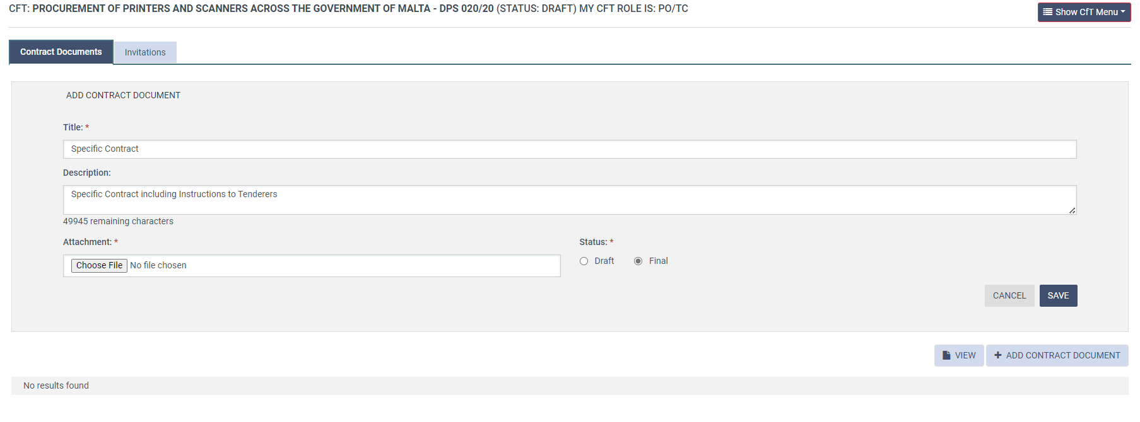

Figure 14 – The **Add Contract Document** screen

## 13.3 Invitation to Specific Contracts

SPDs must invite all Economic Operators admitted to the DPS to take part in the Specific Contract competition, unless otherwise advised by the CPB. This is done by selecting the **invitations** tab from the **cft documents** link within the Specific Contract’s **cft menu**.

|  |
| --- |
| **⮊ Important Note:** If the screen is not displaying any fields, invitations cannot be dispatched since a request for admittance to the DPS is still pending evaluation by the CPB. |



Figure 15 – The **Invitations** screen (no invitation possible)

If the Specific Contract has been finalised, and if there are no pending applications for admittance to the DPS, the **send invitations** task shall be shown on the user’s EPPS homepage.

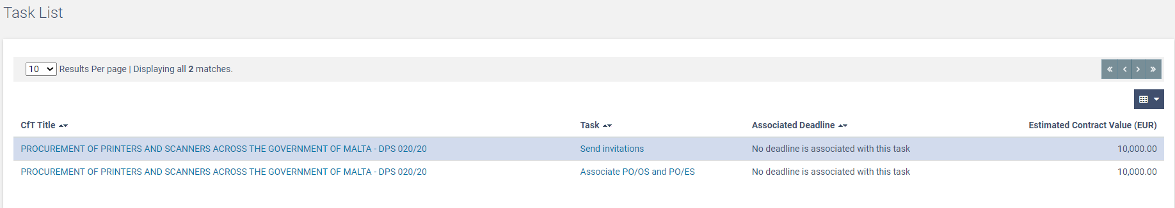

Figure 16 – The **Send Invitations** link in the EPPS Task list.

Clicking the **send invitations** link, leads to the **invitations** tab within the Specific Contract’s **cft documents** section.

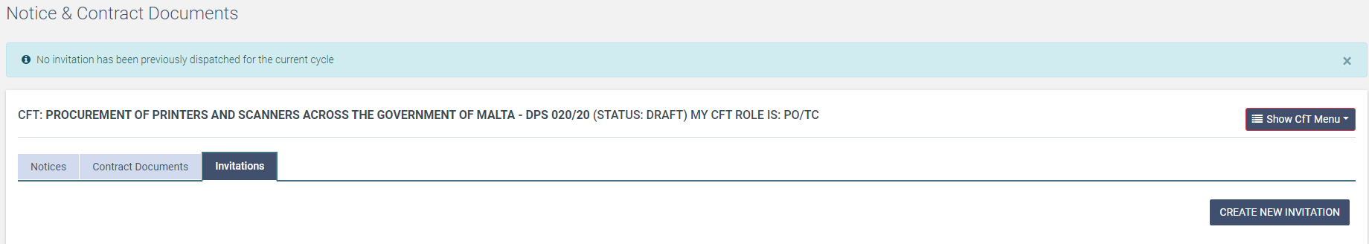

Figure 17 – The **Invitations** Screen.

Invitations are created by clicking the **create new invitation** button.

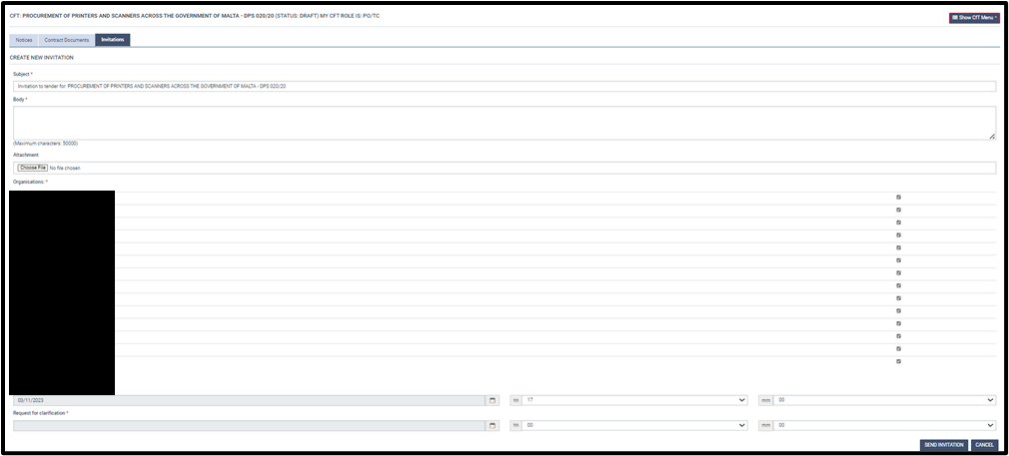

Figure 18 – The **Create New Invitation** Screen.

The invitation is completed by:

* Filling in the body of the Invitation with a brief overview of the subject-matter of the Specific Contract
* Checking **ALL** EOs listed (in alphabetical order) in the screen
* Setting the date and time related to the deadline for tender submission
* Setting the date and time related to the deadline for request for clarification

|  |
| --- |
| **⮊ Important Note:** With respect to deadlines for tender submission, the minimum time-limit for receipt of tenders shall be at least 10 days from the date on which the invitation to tender is sent (as per Regulation 175(3)(b) of the PPR.  There are no minimum time-limits for receipt of clarification requests. The principle of proportionality is to be kept in mind when these deadlines are set. |

The details of organisations admitted to the DPS are pre-filled. Once all information has been set, click the **send Invitation** button to dispatch the invitation.

# Opening and Evaluation of Specific Contracts

The EPPS process once the invitations are dispatched are similar to the conventional Open Tender process. This is a summary of the most salient steps:

## 14.1 Associating users

SPDs will be responsible for the unlocking of tenders and must therefore nominate two (2) opening staff (PO/OS). CAs will be responsible for the evaluation of Specific Contracts and must therefore nominate the voting members of the evaluation committee (PO/ES). Opening staff and Evaluating Staff can be associated through the CfT menu by selecting ‘Associated officers’ and associating users for opening and evaluation.

|  |
| --- |
| **⮊ Important Note:** Evaluating Staff must declare that they do not have any conflict of interest through EPPS in order to be able to evaluate the bids received. This task is only available once bids are unlocked by the Opening Staff. Until such time, the EPPS shall display a task to associate the PO/OS, PO/ES and PO/ESR in the PO/TC’s homepage task list. |

## 14.2 Opening

On accessing the EPPS, opening staff will be able to unlock tender through their task list by selecting ‘Unlock Tenders’.

The first PO/OS is to ensure all bids submitted have been selected by selecting the appropriate tick boxes and then selecting ‘Submit List of Tenders’.

The second PO/OS, on selecting ‘Unlock Tenders’ from his/her task list, will be able to unlock the tenders submitted by selecting ‘Approve list of Tenders’

Once both opening staff have unlocked the tenders, a list of opened tenders will be visible and the opening report can be downloaded by selecting ‘Download’. The minutes of tender opening must be signed by opening staff and retained for the CA’s records.

## 14.3 Evaluation

Once unlocked, submissions must be evaluated by the voting members of the Evaluation Committee solely on the technical and financial criteria as detailed in the Invitation Document. On selecting ‘Evaluate Tenders’ from their task list, evaluators will be directed to the main evaluation page in which only the Technical and Financial criteria tabs will be visible. Where necessary, clarifications and/or rectifications may be sought by the Evaluation Committee through email.

Evaluators have the option of saving their evaluation as draft by selecting ‘Save as Draft’ to allow further updates to be done; if the evaluator has finalised the evaluation and no further updates will be required, he/she can select ‘Save as Final’.

The Chairperson (PO/ESR) must approve the evaluation of all the evaluators by:

* Selecting ‘Overall evaluation status’
* On the page displaying the list of evaluation scores from all evaluators, select ‘Finalise the Evaluation’ for all offers.
* The status of all evaluations will be changed to ‘Finalised’
* Offers will be ranked by the system according to the evaluation

The chairperson must then select ‘Generate Evaluation report’ and an Excel document will be created with the details of the evaluation.

Contracting Authorities must compile the evaluation report and the Chairperson is to upload the report signed by all members of the Evaluation Committee on EPPS. By selecting ‘Upload New Version. Evaluators will receive a task on EPPS to approve the final evaluation report.

Contracting Authorities are to seek the necessary authorisations (internal, DCC, MPU etc.) in order to award the Specific Contract to the successful bidder according to their own authorisation levels/procedures for the award of Specific Contracts.

|  |
| --- |
| **⮊ Important Note:** SCs estimated below €10,000 require the approval of the Head of CA. DCC approval is only required where the SC is estimated from €10,000 upwards. |

Once approval is received, the Chairperson is to ‘Approve as Final’ the evaluation report and the ranking of tenderers is generated.

The Notice of Award is to be uploaded in the Specific Contract’s **cft documents** Section, and sent to all bidders in the respective notifications to successful and unsuccessful bidders. A ten-day appeals period is to be allowed for.

|  |
| --- |
| **⮊ Important Note:** The appeals period only applies where the estimated value of the Specific Contract is in excess of €5,000. Specific Contracts below this threshold need not provide for the procedure for submission of appeals. |

# Award and Post-Award Obligations

## 15.1 Contract Award

Once the appeals period has lapsed, SPDs are to finalise the process on EPPS and award the contract to the successful tenderer, by selecting ‘Award Contracts’. SPDs are to inform the successful tenderer to formally accept the Contract Award through EPPS.

SPDs are to finalise the EPPS process by generating and publishing the Award Notice as follows:

* From the CfT menu select **cft documents**
* In the notices and contract documents page, select **create notice**
* Select **award notice** (no TED publication)
* In the Form Filing Tool, fill in the mandatory fields and on completion, select **save final**. Some fields may be pre-populated.
* The Contract Award Notice will be listed with the earlier Contract Notice and the status will be ‘Final’.
* In the notices page, select the Contract Award Notice and press **publish notice**. The status of the award notice will change to ‘Published’.

SPDs are to ensure that they inform the CPB of the award of any Specific Contract and the value of the awarded Contract by sending a copy of the Contract Award Notice on [dps.mita@gov.mt](mailto:dps.mita@gov.mt).

## 15.2 Populating the Specific Contract

The Specific Contract template, as published with the Invitation Document, must then be compiled by the SPD following the steps below:

* Fill in greyed out details including:

1. Date
2. Address of tenderer
3. Contracting Authority details
4. Tenderer details
5. Total charges for the Specific Contract
6. Technical specifications as published in Invitation in Appendix A
7. Training requirements as published in Invitation in Appendix A
8. Include Price Schedule as submitted by Tenderer in Appendix A
9. Include Supplier’s Technical Offer as Appendix B
10. Attach Performance Guarantee as provided by Supplier as Appendix F

* Contact successful bidder for any missing details example, VAT number, company registration, signatory details.

Once the Specific Contract is compiled, the signatory for the CA must sign two copies of the Po/LoE and these are to be sent to successful bidder for counter-signature. The CA is to retain one counter-signed copy for their record. The contract shall only be sent for endorsement after the mandatory lapse of the 10 calendar days appeal period and confirmation that no appeal has been lodged with the Public Contracts Review Board (PCRB).

## 15.3 Post-Award Obligations

After the completion of the Specific Contract process and endorsement of the Contract, CAs are to:

* Ensure Suppliers provide the CA with a Performance guarantee (where applicable), in accordance with the Contract provisions;
* Notify Suppliers of any police conduct certificates and/ or Security screening certificates, as the CA may deem necessary;
* Monitor performance under the Contract;
* Ensure the Supplier abides by the period of delivery specified in the Contract and enforce penalties if necessary;
* Issue acceptance certificate/ delivery note on delivery of the equipment;
* Process invoices and payments according to the Contract provisions;
* Ensure the Supplier adheres to the SLAs specified in the Contract and enforce penalties if necessary;
* Draft any contractual amendments that may become necessary during the Term, after obtaining the appropriate approvals;
* For leasing, ensure the CA abides by its responsibilities as a Lessee, as outlined in the Contract.
* Follow-up the contract right up until completion, where the relative Completion Report is to be completed by the CA.

F O R Z A M I L A N

# Useful References, Websites and Contact Details

|  |
| --- |
|  |
| **References** |
|  |
| **Public Procurement Regulations (S.L. 601.03)**  <http://www.justiceservices.gov.mt/DownloadDocument.aspx?app=lom&itemid=9532&l=1> |
| **Interoffice Memorandum - Procurement of Printers, Scanners and related supplies-services** |
| <https://www.etenders.gov.mt/epps/dps/viewDPSRestrictedArea.do?resourceId=6327482&ceproc.msg.confirm=prompt.upload.document.in.restricted.area>  *You need to be logged in to EPPS and your Organisation associated with this DPS in order to access the file* |
|  |
| **Websites** |
| **EPPS Link for DPS 020/20 – Procurement of Printers and Scanners**  <https://www.etenders.gov.mt/epps/dps/prepareViewCfTDPSWS.do?resourceId=6327482> |
| **DPS Contract Notice in the Official Journal of the EU**  <https://ted.europa.eu/udl?uri=TED:NOTICE:132129-2020:TEXT:EN:HTML> |
| **EPPS Resources Link (to download General Rules Regarding DPS/Tenders)**  <https://www.etenders.gov.mt/epps/viewInfo.do?section=statistics&selectedItem=viewInfo.do%3Fsection%3Dstatistics> |
|  |
| **MITA Procurement Website dedicated page**  <https://procurement.mita.gov.mt/resources/dps/dps-printers-scanners/> |
|  |
| **​Waste Electrical and Electronic Equipment (WEEE)**  <https://era.org.mt/en/Pages/WEEE.aspx> |
|  |
| **Useful email addresses** |
| **MITA Manager (Contracts and Legal) and MITA DPS Team**  [dps.mita@gov.mt](mailto:dps.mita@gov.mt) |
| **Office of the Prime Minister (DPS Liaison)**  [dps.opm@gov.mt](mailto:dps.opm@gov.mt) |
| **Sectoral Procurement Directorate at OPM**  [spd.opm@gov.mt](mailto:spd.opm@gov.mt) |
| **Department of Contracts (EPPS Liaison)**  [etenders@gov.mt](mailto:etenders@gov.mt) |
|  |

# Appendix A

**MITA Dynamic Purchasing Systems Process Flow**

**Contracting Authorities listed in Schedule 16**

|  |  |  |  |
| --- | --- | --- | --- |
| **Task** | **Responsibility** | | |
| **MITA** | **SPD** | **CA** |
| **DPS Administration** |  |  |  |
|  |  |  |  |
| Administering the establishment of the DPS | **🗸** |  |  |
| Making available templates and guidance notes including updating as necessary | **🗸** |  |  |
| Admittance of SPD and CAs | **🗸** |  |  |
| Evaluation of applications for admittance to the DPS by interested suppliers and admitting/ rejecting accordingly | **🗸** |  |  |
| Monitoring of budget associated with DPS | **🗸** |  |  |
|  |  |  |  |
| **Specific Contract Publication** |  |  |  |
|  |  |  |  |
| Filling in templates made available for Specific Contracts |  |  | **🗸** |
| Drafting of Terms of Reference and/or technical specifications |  |  | **🗸** |
| Seeking GPP clearance where necessary |  |  | **🗸** |
| Obtaining internal authorisations for specific contracts, including signature of Procurement Originators Form (PoF) |  |  | **🗸** |
|  |  |  |  |
| **⮊ *If the value of the Specific Contract is below €10,000:*** |  |  |  |
| Seek guidance/assistance from MITA in relation to Specific Contract drafting |  |  | **🗸** |
| Creation of EPPS XML structure |  |  | **🗸** |
| Dispatch of invitation to admitted candidates |  |  | **🗸** |
| Sending copy of signed PoF to MITA, prior to publication |  |  | **🗸** |
| Tender unlocking |  |  | **🗸** |
|  |  |  |  |
| **⮊ *If the value of the Specific Contract exceeds €10,000:*** |  |  |  |
| Vetting of SC documentation from CAs |  | **🗸** |  |
| Seek guidance/assistance from MITA in relation to Specific Contract drafting |  | **🗸** |  |
| Creation of EPPS XML structure |  |  | **🗸 \*** |
| Dispatch of invitation to admitted candidates |  | **🗸** |  |
| Sending copy of signed PoF to MITA, prior to publication |  | **🗸** |  |
| Tender unlocking |  | **🗸** |  |
|  |  |  |  |
| **Specific Contract Adjudication and Post-Award** |  |  |  |
|  |  |  |  |
| **⮊ *If the value of the Specific Contract is below €10,000:*** |  |  |  |
| Evaluation of specific contracts |  |  | **🗸** |
| Finalisation of process on EPPS including awarding of contract, informing successful and unsuccessful tenders of outcome, creating award notice and contract on EPPS. |  |  | **🗸** |
| Populating Letter of Engagement/ Purchase Order following award |  |  | **🗸** |
| Signature of Specific Contract |  |  | **🗸** |
| Sending copy of Contract Award Notice to MITA, following award |  |  | **🗸** |
| Contract management including receipt of performance guarantees, monitoring performance, issuing delivery notes, payments, adherence to contractual obligations, drafting amendments, completion reports. |  |  | **🗸** |
|  |  |  |  |
| **⮊ *If the value of the Specific Contract exceeds €10,000:*** |  |  |  |
|  |  |  |  |
| Evaluation of specific contracts |  |  | **🗸** |
| Finalisation of process on EPPS including awarding of contract, informing successful and unsuccessful tenders of outcome, creating award notice and contract on EPPS. |  | **🗸** |  |
| Populating Letter of Engagement/ Purchase Order following award |  | **🗸** |  |
| Signature of Specific Contract |  |  | **🗸** |
| Sending copy of Contract Award Notice to MITA, following award |  | **🗸** |  |
| Contract management including receipt of performance guarantees, monitoring performance, issuing delivery notes, payments, adherence to contractual obligations, drafting amendments, completion reports. |  |  | **🗸** |

* Unless SPD advises otherwise

# Appendix B

**MITA Dynamic Purchasing Systems Process Flow**

**Contracting Authorities listed in Schedules 2 and 3**

|  |  |  |  |
| --- | --- | --- | --- |
| **Task** | **Responsibility** | | |
| **MITA** | **SPD** | **CA** |
| **DPS Administration** |  |  |  |
|  |  |  |  |
| Administering the establishment of the DPS | **🗸** |  |  |
| Making available templates and guidance notes including updating as necessary | **🗸** |  |  |
| Admittance of SPD and CAs | **🗸** |  |  |
| Evaluation of applications for admittance to the DPS by interested suppliers and admitting/ rejecting accordingly | **🗸** |  |  |
| Monitoring of budget associated with DPS | **🗸** |  |  |
|  |  |  |  |
| **Specific Contract Publication** |  |  |  |
|  |  |  |  |
| Filling in templates made available for Specific Contracts |  |  | **🗸** |
| Drafting of Terms of Reference and/or technical specifications |  |  | **🗸** |
| Seeking GPP clearance where necessary |  |  | **🗸** |
| Obtaining internal authorisations for specific contracts, including signature of Procurement Originators Form (PoF) |  |  | **🗸** |
| Seek guidance/assistance from MITA in relation to Specific Contract drafting |  |  | **🗸** |
| Creation of EPPS XML structure |  |  | **🗸** |
| Dispatch of invitation to admitted candidates |  |  | **🗸** |
| Sending copy of signed PoF to MITA, prior to publication |  |  | **🗸** |
| Tender unlocking |  |  | **🗸** |
|  |  |  |  |
| **Specific Contract Adjudication and Post-Award** |  |  |  |
|  |  |  |  |
| Evaluation of specific contracts |  |  | **🗸** |
| Finalisation of process on EPPS including awarding of contract, informing successful and unsuccessful tenders of outcome, creating award notice and contract on EPPS. |  |  | **🗸** |
| Populating Letter of Engagement/ Purchase Order following award |  |  | **🗸** |
| Signature of Specific Contract |  |  | **🗸** |
| Sending copy of Contract Award Notice to MITA, following award |  |  | **🗸** |
| Contract management including receipt of performance guarantees, monitoring performance, issuing delivery notes, payments, adherence to contractual obligations, drafting amendments, completion reports. |  |  | **🗸** |